Japan's Participation in YOTA
(Youngsters on the Air)
JR2KHB Riku SUDA (jr2khb@jarl.com)
JE1XUZ Seiya KATO (je1xuz@jarl.com)
August 3, 2018

Abstract
Youngsters on the Air, or YOTA, is a large project under the IARU R1 committee which encourages and nurtures young amateurs.
YOTA started as a volunteer group in 2011 targeting Europe, with its basic idea: “BY youngsters, FOR youngsters, FROM the VIEWPOINT of youngsters." It has been really successful in Europe, Africa, and the Middle East in recent years.
In August 2017, two Japanese young amateurs, JE1XUZ S. Kato and JR2KHB R. Suda visited London to participate in YOTA UK summer camp, as the first YOTA participants from Asia & Pacific region (IARU Region 3). Inspired by vivid experiences during the event, they launched "YOTA Japan" in December 2017 to import YOTA's idea into Japan and Asia & Pacific region, and to welcome new young hams and encourage them to be sophisticated amateurs suitable for the 21st century. YOTA Japan is now discovering novel ideas from young amateurs and making a sketch of new ham radio world throughout its events and activities.

- About YOTA
YOTA (Youngsters On The Air) is a youth cultivation project for radio amateurs mainly under the age of 26, sponsored by the IARU Region 1 (Fig. 1.1).
YOTA holds the world convention called "YOTA Summer Camp" each year in different countries in IARU R1. Along with the curriculum developed by experts in education, the participants experience as many kinds of ham radio activities as possible in 7 days, such as ARDF, DX, contesting, digital modes, contacts via satellites, kit building, and ARISS contact. Sightseeing in the host country and some intercultural activities are also scheduled during the summer camp. The summer camp "YOTA South Africa 2018" is going to be held on August 8 - 15 at Johannesburg.
They consider the concept “BY youngsters, FOR youngsters, FROM the VIEWPOINT of youngsters" as the key to success. YOTA has skilled youngsters be leaders. The young leaders train other young participants and play core roles of planning and management in YOTA events. YOTA places great importance on listening to youngsters' voice and on understanding their ideas and the subjects of their interest.

Figure 1.1: The logo of YOTA

2 YOTA UK 2017 Summer Camp
On August 5-12, 2017, the summer camp "YOTA UK 2017" were held at Gilwell Park located in the suburb of London. In addition to 78 participants from 26 countries in IARU R1, 2 young hams from Japan, JE1XUZ S. Kato (24 y/o at that time) and JR2KHB R. Suda (20 y/o at that time), were invited to this camp (Fig. 2.1, 2.2). While some participants were quite skilled amateurs, others were newcomers who were interested in electronics but didn't have amateur license. Most of the participants were under the age of 26.
The host society, RSGB (Radio Society of Great Britain), established a special event station GB17YOTA (Fig. 2.3). All the participants were exceptionally permitted by U.K. administration, Ofcom (Office of Communications), to operate it on 80 - 4m bands with 500 W power under supervision, regardless of their radio licenses. GB17YOTA made more than 10,000 QSOs during whole the event period.
Every YOTA camp gains a lot of support from adults in all aspects of human resources, money and supplies. Besides the cooperation from national radio societies of the host country, several huge DX funds and companies related to ham radio donates to YOTA activities. As a result, the participation fee can be reasonable. The participation fee for YOTA UK (excluding transportation costs to the site) was only 44 British Pounds (58 USD) per person. We appreciate that we could receive various kinds of cooperation from several elder Japanese hams, and subsidy from JARL (Japan Amateur Radio League) for transportation.
To create this large movement, YOTA and RSGB make a great effort for promotion. They have been making good use of YouTube, Facebook, and Twitter. Daily reports of the summer camp had been uploaded for the whole seven days (see "the RSGB" channel on YouTube.)
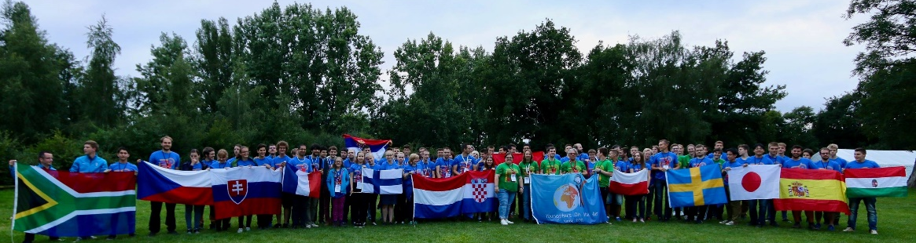
Figure 2.1: 80 youngsters from 27 countries gathered at YOTA UK 2017
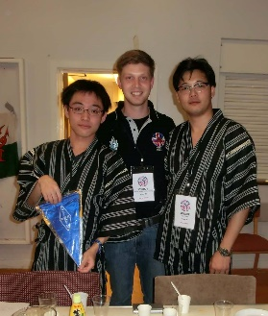 | 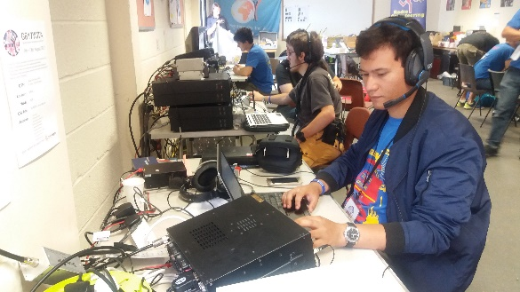
Figure 2.2: Intercultural program | Figure 2.3: GB17YOTA operation

3 Establishment and Activities of YOTA Japan
We, Kato and Suda, were greatly inspired by vivid experiences during YOTA UK summer camp. We decided to import YOTA to Japan, or even to IARU R3, in order to cultivate young amateurs in our area and to make ham radio world active, sophisticated, valuable, and suitable for 21st century.
At Tokyo Ham Fair 2017, held in September, we invited PA2LS Lisa Leenders, who is the chair of Youth WG of IARU R1 and overall YOTA coordinator (Fig. 3.1).
Kato, Suda, and some youngsters launched "YOTA Japan" in December 2017, together with several famous DX'ers and contesters as supporters. We are to produce suitable communities for youngsters to achieve our goals described above.
First of all, we have been focusing on listening to youth, which is the most basic idea of YOTA. We visit school ham clubs and make interviews to students, in order to discover and understand their opinions and ideas on ham radio. These reports are shared as articles on "CQ Hamradio" (by CQ Pub.), the most famous ham magazine in Japan (Fig. 3.2).
We have held small YOTA events as well, like "Youth Contesting Program (YCP)" that gives youngsters opportunities to enjoy contesting.
Lots of young hams are active and keen on contesting. It is also true that, however, most youngsters have only few opportunities to enjoy contesting in wonderful environments (good equipment, good members, and good location). Based on these facts, YOTA holds YCP events and invites youngsters to the so-called “super stations” which have great environments for contesting. For example, 4O3A (Montenegro) and 9A1A (Croatia) are served as YCP stations in Europe.
YOTA Japan have held 2 YCPs so far.
The first one was held on Mar 24-25 2018 (UTC) where 7 youngsters (16-25 y/o) gathered at JE1CKA, a world-famous contest station, and enjoyed CQ WPX SSB Contest (Fig. 3.3). Comments from the participants are available on the web site of YOTA Japan.
The second YCP was planned for relatively beginners and aimed to teach them basic skills for contesting or to improve their techniques. The participants took part in Shizuoka Contest, one of local contests in Japan. Two large stations which locates in Shizuoka prefecture were offering the cooperation, and young participants were able to operate there.
In addition, at some ham events in Japan, we have exhibitions and seminars to share YOTA's ideas and our discovery that are gained through our YOTA events.
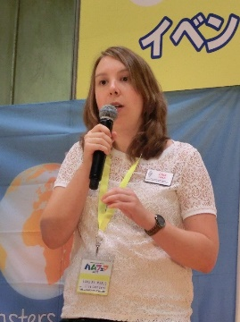 | 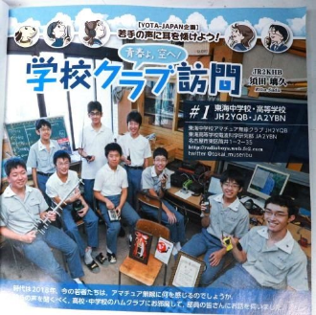 | 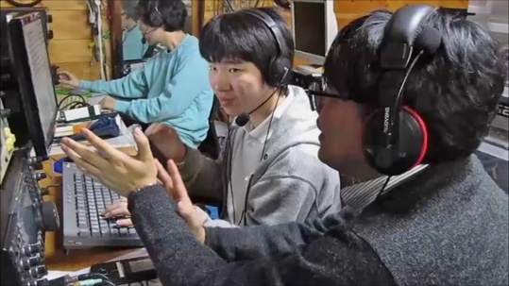
Figure 3.1: PA2LS lecturing at Tokyo Hamfair 2017 | Figure 3.2: Article introducing  a school ham club | Figure 3.3: YCP at JE1CKA in March 2018

4 Suggestion
In order to overcome the crucial problem of the decline of amateur radio, we YOTA and YOTA Japan propose the followings:
4.1 Consider what we can do more to get youth interested in ham radio.
How should we advertise ham radio effectively to young people? What elements of amateur radio can attracts youngsters living in 21st century? We never can make good promotions of ham radio without reconsideration and essential discussion of its delights.
We might need to make the frame of amateur radio broader than it in 20th century. Today there are many kinds of interests in the radio hobby which had not existed a few decades ago. Even if points of their interest are unfamiliar to oldsters, we should accept them as the citizens of ham radio world. Listening to youngsters' voice could help us discover new aspects of ham radio, which can be the trigger for amateurs' renaissance.
Furthermore, as many channels and aspects of amateur radio as possible should be offered to youngsters, in order to prevent them from getting tired of ham radio easily. Youth always gains interest fast, but loses it also fast.
4.2 Let youth organize youth events and projects.
It is necessary to stand on the viewpoint of youth in order to make effective projects for youth. In some cases, quite novel ideas could be needed.
Youngsters are able to do it. That is the reason why YOTA is focusing mainly on "youth" between the ages of 15 to 26, not on "children".
Youth is enthusiastic. Give an opportunity to youngsters to produce youth event. It should be beneficial for both youngsters and oldsters. That is YOTA spirits.
4.3 Make YOTA participants ambassadors for amateur radio.
It should be meaningful as well that such enthusiastic youths with various ideas meet together and make discussions beyond any borders, by that they can broaden not only their amateur community but also ham radio world itself. YOTA events provide proper environments for such spontaneous activities of youngsters.
We expect the youngsters to become "ambassadors for amateur radio" and to play core roles to create the future of amateur radio.
4.4 Spread the word.
To realize YOTA's goal, we have to pick up more and more youngsters. We strongly hope every societies of radio amateurs to support, encourage, and cultivate young hams, and to pay attention and listen to their ideas.
Spread this concept of 21st century's youth project that improves this marvelous radio hobby and makes it sustainable. Youngsters have enough potential to solve our aging problem.

See Also
- YOTA Japan (http://jouban.jp/yota-ja/)
- Youngsters on the Air (https://www.ham-yota.com/)

© RSGB & HAM-YOTA
© RSGB & HAM-YOTA
© RSGB & HAM-YOTA
CQ ham radio, vol.73 (2), 24-26. Feb 2018. Riku Suda.

