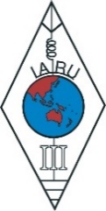 | INTERNATIONAL AMATEUR RADIO UNION  REGION 3  SEVENTEENTH REGIONAL CONFERENCE | 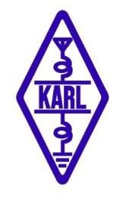
10 – 14 September 2018 Seoul, Korea

Document No. 18/XVII/029
Agenda Item: 12.7

Amateur Radio for Kids

Julie Gonzales VK3FOWL and Joe Gonzales VK3YSP

With an aging membership and our precious frequency bands under threat from commercial interests, Amateur Radio may seem like it is in very dire straits. Many Amateur Radio operators who lament this situation are doubtful there is any real solution. Some even consider the demise of Amateur Radio inevitable – It has “had its day” they say. We know this because we visit many Amateur Radio clubs in our area and we have presented our ideas to their committees and members alike. The feedback we get, sometimes, even tests our own enthusiasm for what we regard as a truly remarkable and rewarding hobby and a potential asset to our local schools and communities.

This paper addresses how we are trying to reinvigorate and repurpose Amateur Radio in a fundamental manner: At home, in our schools, our clubs and our communities. We believe that every current member of the Amateur Radio fraternity, including our clubs, national and international associations, has a duty to preserve, promote and pass on the privilege of Amateur Radio to the next generation, as it was entrusted to us. We are not getting any younger and we are simply not doing enough!

Amateur Radio is all about technical self-education, experimentation and even fostering international good will. It is not just a licence to communicate, it is a licence to have a privileged conversation with our esteemed colleagues in a unique and irreplaceable format. It is not for commerce, entertainment or advertising, it is the pursuit of fundamental principles, the expression of our hard-earned knowledge and the advancement of our skills and abilities. Amateur Radio is simultaneously art, science and sport.

Amateur Radio clubs actively support local community activities and provide free communications for public events. Through club meetings and organised presentations they provide an enriching environment for experimentation, construction, technical advancement and social activities. On a more serious level, Amateur Radio civil emergency networks are always ready to provide emergency communications in case of natural disaster. Amateur Radio operators are skilled, practical folk with a can-do attitude.

In our opinion, many operators don’t even realize what a fundamental and positive influence Amateur Radio has had in their own lives and the wider impact of it in our communities and industries. Indeed, Amateur Radio has many heroes:

“Ten years of fascination with amateur radio in the 1950s and early 1960s led me to a professional life in basic research and university teaching. Over the next forty years, my research in radio astronomy taught me a great deal about extracting extremely weak signals from noise, and analyzing their content. In 2001, back on the air as an active radio amateur, I began thinking about ways to apply techniques learned and developed in the research world to the problems of weak‐signal communication on our VHF and UHF bands.” ‐ Dr. Joe Taylor. K1JT, Albert Einstein medal and Nobel Laureate.

We often ask the Amateurs we meet a fundamental question: “When did you first get interested in radio and electronics.” The answer is invariably something like this: “When I was five or six years old, my dad gave me an old wireless set to pull apart.” So, we began wondering if there was anything similar available today to inspire and influence the youngest members of our community into this fascinating field? Well, have you ever tried pulling apart a mobile phone? It’s impractical. We also found that our local primary schools often didn’t have the necessary class resources and their teachers were looking for more practical ways to introduce STEM learning into their curriculum. So, by being in the right place at the right time, we were able to set up three primary school Amateur Radio clubs and we started the School Amateur Radio Club Network (www.sarcnet.org). The success of this program has been encouraging, to say the least. With small groups of students engaged each week in a fun, lunchtime session of radio and electronics activities. The kids love to be a member of their own club and they learn to work together on some pretty challenging missions. Graduates of the program are then able to continue with their projects during weekly workshops, which we conduct after school at our local Amateur Radio club rooms. All of this, simply using the readily available resources of our hobby.

“It is interesting that in this day and age of mobile broadband networks and social media that Amateur Radio, the pioneering radio hobby of the last century, would be an excellent way of introducing science and technology to young children today. Amateur Radio enthusiasts are an amazing, untapped resource for educators. They are hidden away in every community, and can provide their own equipment and expertise. They also have a zeal to pass on this technology to the next generation. And, I would say, their aging ranks could do with some new recruits from us. So, this largely free and enriching collaboration between the schools and the Amateur Radio fraternity is a classic win‐win situation.” – Primary School Principal, Michael Day.

Our next challenge is to inspire individual Amateur Radio operators, their clubs and national associations to get moving and implement their own weekly youth programs. In conclusion, we provide a short list of our recommendations, for consideration by the members of the IARU:

Individual Amateur Radio operators should:
- Reach out to younger family members and children of friends and neighbours.
- Promote ham-shack special events: Entertaining DX nights, youth on-air skeds.
- Organise radio and electronics home construction nights.
- Set up portable stations for school, church and community events with youth activities and prizes.
- Operate portable in parks, summits, lighthouses and museums to get kids on-air.

Our Amateur Radio clubs should:
- Establish a position for youth members on the club committee.
- Establish a youth membership policy (free to under 18s, no licence required).
- Establish weekly youth programs, special interest groups, activities, workshops, construction/deconstruction nights and suitable club projects.
- Participate in National Science Week and local Science Fairs. Setup youth exhibitions with kids promoting Amateur Radio.
- Organise youth field trips (with parents) for SOTA, WWFF, Field Day Contests.
- Provide free out-door Amateur Radio activities for school excursions.
- Inaugurate youth on-air contests with awards for participation.
- Reach out to schools, Cubs, Scouts and other youth community groups.
- Establish a School Amateur Radio Club: Roster members and raise funds.
- Promote the environment: Ban lead solder. Recycle and repurpose e-waste.

Our national Amateur Radio associations should:
- Establish a position for youth membership on the board of directors.
- Establish a youth committee chaired by a youth member.
- Establish national guidelines for Amateur Radio club youth programs.
- Establish national guidelines for School Amateur Radio Clubs.
- Establish national Youth-On-The-Air contests.
- Reinstate shortwave listener licences with competitions.
- Establish a regular youth column in the association’s magazine.
- Promote and sponsor individual or club Amateur Radio youth programs.

Engaging youngsters at an early age in radio and electronics should not be all about Amateur Radio recruiting or Foundation Licencing. A conceited approach to it will be counter-productive. It should be about genuinely inspiring in our children a natural curiosity and hands-on relationship with science and technology. Amateur Radio is both a perfect resource to achieve this outcome and it can also be an on-going expression of their desire to learn and do more. Encouragement at an early age is essential. Our one guiding principle in this important endeavor is: “It is not about us, it is all about the kids.” We hope you will join us, because the children are indeed our future.

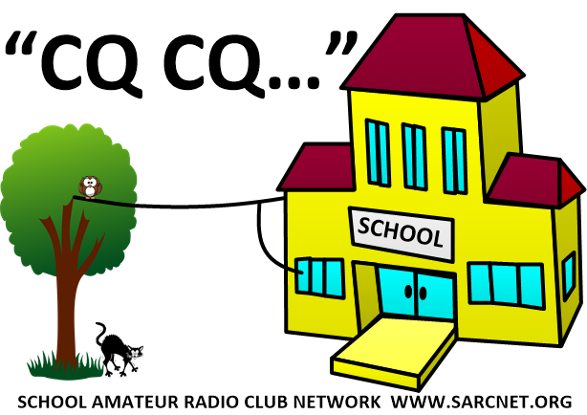
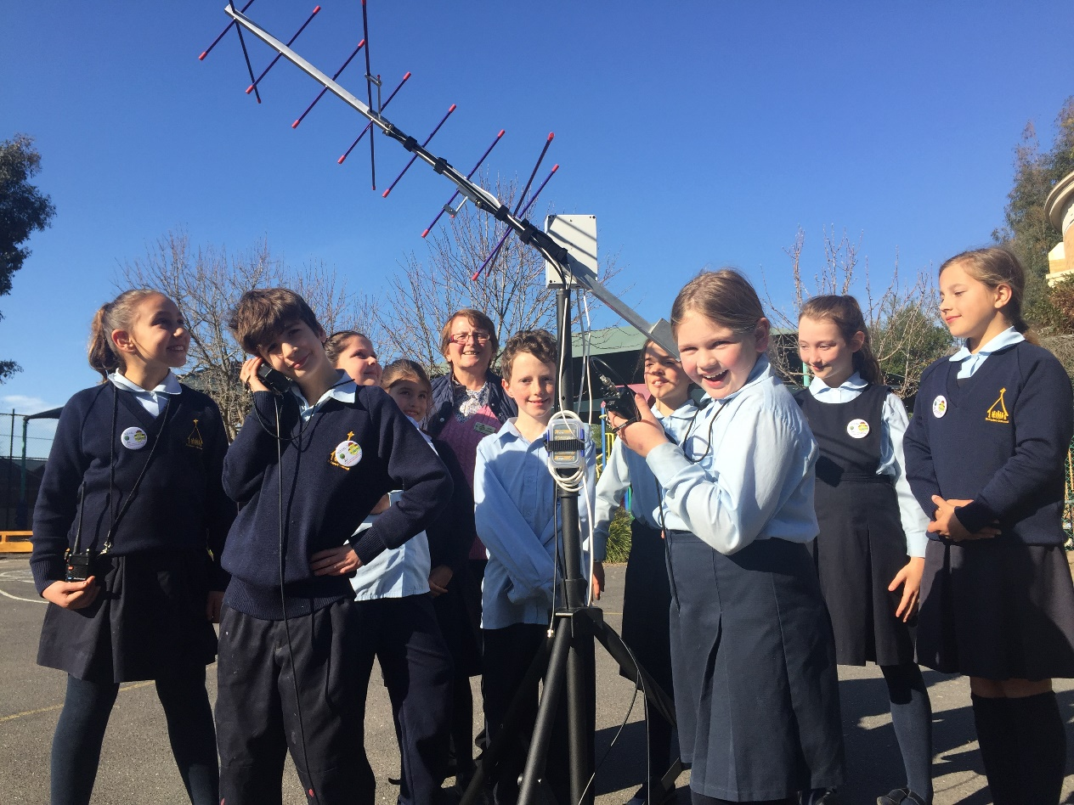
School Amateur Radio Club students tracking Amateur Radio satellites

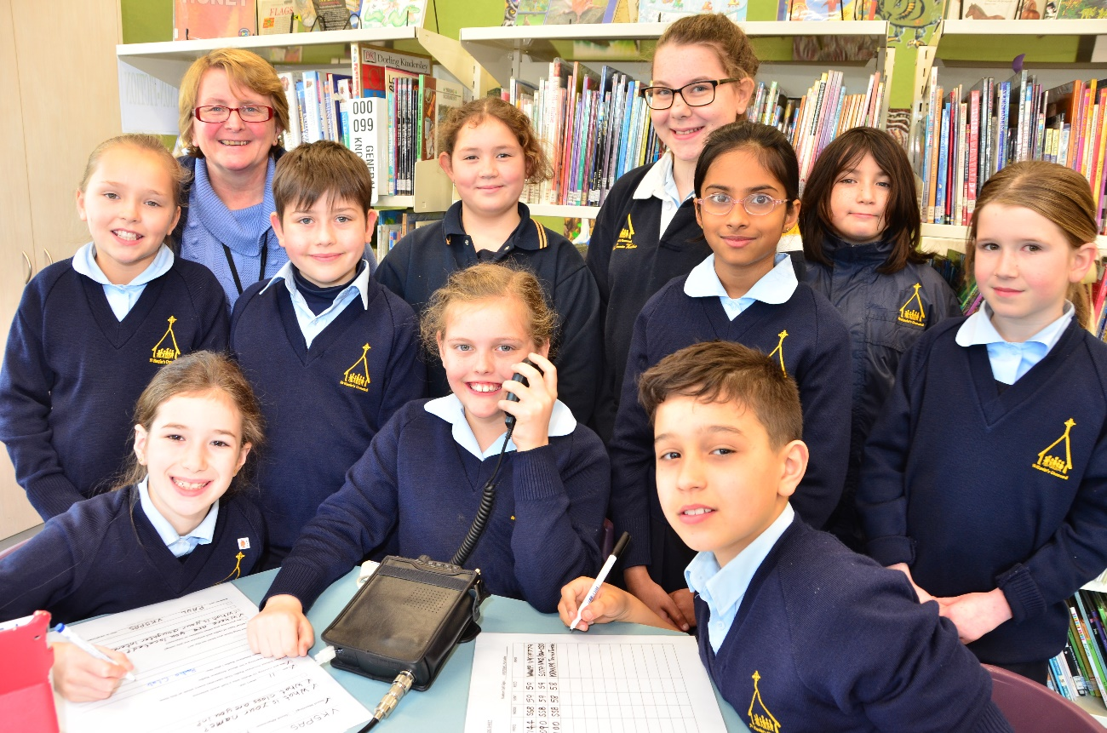
School Amateur Radio Club students calling CQ on shortwave radio

Recommendation: That the conference note the content of this paper for further discussion
____________________

