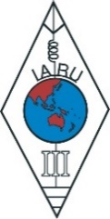 | INTERNATIONAL AMATEUR RADIO UNION  REGION 3  Seventeenth Regional Conference | 

10 – 14 September 2018
Document No. 18/XVII/048
Agenda Item: 10.1

Report of Chinese Taipei Amateur Radio League (CTARL)

CTARL membership:

until 2018, there are total 415 members (including 235 life members) in our Society. The individual annual membership fee is remained NTD600 (around USD20) and the life membership fee is NTD7200 (around US$240).

Regulation improvement

During the years, we’ve been fought for new regulation from our Registration. Finally we have some progress.
- CW is no longer required for radio licenses exam
- All licenses duration extend from 5 years to 10 years.
- All questionnaire for all licenses has been greatly modified and improved.
- Open the setup for repeater, beacon radio and special event radio.
- New frequency allocation established.

Special international events:

There are some international events hosted in Taiwan and CTARL is managing the special amateur radio stations to promote and celebrate these events to people in Taiwan and all over the world.
- BV0FISU
Event: Universiade
Date: 2017/8/19-30
The XXIX Summer Universiade held in Taiwan.

- BV0SM:
Event: ARISS
Operation period: 2016/8/2
“Talk to Astronaut on ISS” was held at Scared-Heart elementary school in New Taipei City.

- BN0SH:
Event: ARISS
Operation period: 2017/12/21
“Talk to Astronaut on ISS” was held at Taoyuan City government plaza for students of Shih-Meng elementary school.

- JOTI-JOTA:
Event:
Boy scouts’ Jamboree on the air
Operation period: 2016/10/14-16
2017/10/20-22
Call sign: BV0BSO BV0BSD BV0BSG BV0BSI BV0BSB BV0BSP BV0BSY BV0BST BV0BSN BW0S

5. BP0T
Event: Experiment of Taipei City University of science and technology. It was held in I-Lang County. The last altitude signal received from APRS airborne bloom (probe) was at 31753m.
Operation period: 2018/3/3

6.BV18FIFA
Event: FIFA world cup 2018 radio marathon activity
Operation period:

7.BV50IARU
Event: Radio for 50 Anniversaries for IARU Region 3
Operation period: 2018/05/23-2018/10/31

Administration Amateur Radio Frequency allocations:

The following is the list of the amateur radio frequency allocation proposals proposed by CTARL to the national administration and the latest approved frequency allocations. We have tried hard to cooperate with the administration to achieve R3 band plan allocations.

New approval since 15th IARU-R3 conference:
432.00 MHz – 440.00 MHz
50.1225–50.150 MHz
28–28.1 MHz
7.1MHz–7.2MHz
135.7KHz-137.8KHz

Things we’re working on:

CTARL are helping few universities in Taiwan to launch their program of Educational Amateur Radio CubeSat as below:
Taiwan CubeSat Program

The purpose for this CubeSat program is to cultivate next generation talents for space technologies and to generate CubeSat commercial products. The time span for this CubeSats project is from 2017 to 2020 to launch 3 CubeSats. These CubeSat contracts have been issued to Taiwan’s universities and domestic companies in April 2017. The IDEASsat is a 3U type CubeSat, NUTSAT is 2U, and YUSAT-1 is 1.5U.
The educational payload for IDEASSAT (Ionospheric Dynamics Explorer and Attitude Subsystem Satellite) is the Compact Ionosphere Probe (CIP), an all-in-one in-situ plasma sensor developed at National Central University (NCU), based on heritage from the Advanced Ionosphere Probe (AIP) aboard FORMOSAT-5). CIP will be capable of monitoring the thermal, chemical, and electro-dynamic structure of the ionosphere, while also identifying plasma irregularities that can disrupt satellite and terrestrial radio communications through scintillation.
The payload for NutSat is the ADS-B (Automatic Dependent Surveillance - Broadcast) receiver. The technology and devices of ADS-B have been used on commercial airplane for many years while using satellites to track airplane has the benefit for global coverage. The NUTSAT was developed by National Formosa University.
There are two communication payloads, AIS receiver and APRS receiver on YUSAT-1. It was developed by National Taiwan Ocean University and MoGaMe Enterprise. The AIS receiver can receives AIS packets from vessels globally. The AIS packets can be stored on-board, then be dumped to ground stations via UHF frequency. It will improve maritime navigation safety. The APRS receiver can receive APRS messages from cars for traffic monitoring, and from ground sensor devices for large area environmental monitoring.

The IARU Frequency Coordination documents of CubeSat is shown on table below.

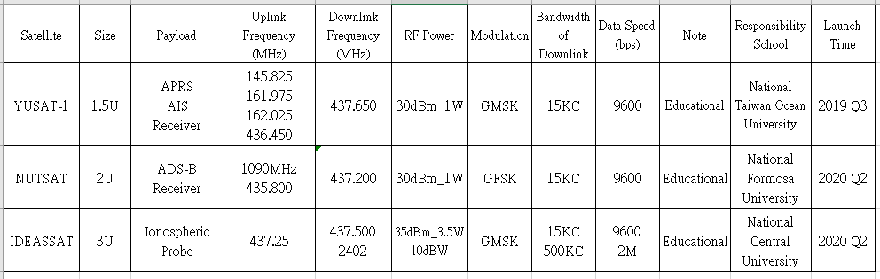
ADS-B: Automatic Dependent Surveillance-Broadcast
AIS: Automatic Identification System
APRS: Automatic Packet Reporting System
Orbit: circular, 450~600km, sun sync

conclusion
Pass three years have been a blossom period for CTARL after put in lots of efforts; we have a well interactive with government and a brighter future for repeaters and beacon radios, wider frequency band to use with. Still we have a long way to go to meet up with IARU and we’re looking forward to do it.

