REPORT ON ITU TELECOM WORLD 2013 – Bangkok, THAILAND 19 – 22 November 2013
This report describes the project actioned by the IARU Region 3 Directors and the IARU, along with the substantial assistance of the Radio Amateur Society of Thailand RAST (under the Patronage of the King). We prepared and ran a booth in the international exhibition associated with the ITU (International Telecommunication Union) “Telecom World 2013” event held in Bangkok in November 2013. We had some previous experience from exhibiting at “Telecom Asia 2008”.
We started working on achieving a presence at this Telecom World event in March 2013, when Chairman of Directors Gopal VU2GMN, visited the ITU regional headquarters in Bangkok and met Dr. Eun-ju KIM, the Regional Director of ITU and her colleagues. He requested help from her to get us some “free” space at the Exhibition. The ITU had stopped allocating free space to anyone after the regional Telecom events were abolished and only Telecom World branded events were being held. IARU and IARU Region 3 could not afford the rental on commercial terms. We did have to pay for the booth construction and other incidental costs.
There were several discussions with ITU officials in Geneva on the telephone, and finally an agreement was reached that would give us 27 sq. m. of space in return for which the IARU would publicize the event on the three regional webpages and information to societies via e-mail.
We met with Dr. Kim and one of her colleagues Wisit Atipayakoon again in July, along with the President of RAST Joe (Pornchai) Semjang HS2JFW and Tony Waltham HS0ZDX the Vice President. Further plans were worked out. At that time the ITU wanted to have a much greater cooperation between ITU and IARU.
RAST were very happy to assist and provided the radio station, computers, other equipment and manpower by way of local Thai radio amateurs to man the booth. Director Peter Lake ZL2AZ made the journey specially to assist during the exhibition.
The exhibition was held at the IMPACT Arena in Muang Thong Thani, an excellent exhibition and meeting centre, located in northern Bangkok.
The IARU booth was in a very strategic location, just opposite the Media Centre, and along a main walkway.
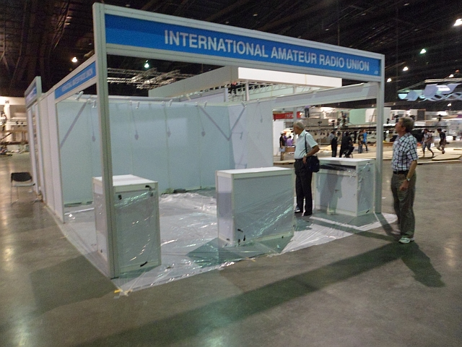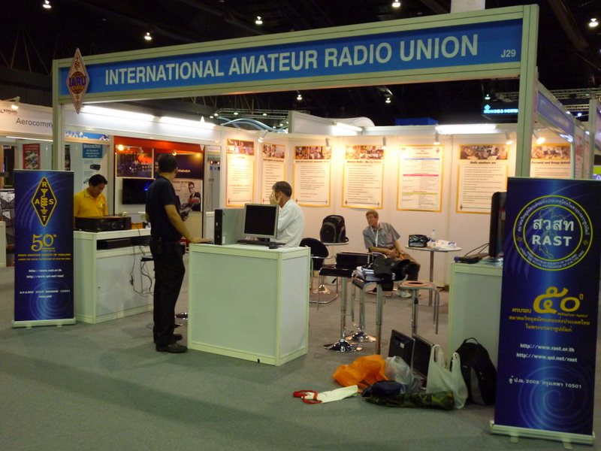
The booth as first seen and later being setup the day before the exhibition opened
Specially designed posters setting out the various aspects of amateur radio were printed in India, and used on the walls of the booth. There were also posters depicting the activities of RAST. Brochures in English and Thai describing amateur radio were also prepared and available for distribution.

We had a number of high profile visitors to the booth, including Ministers of Communications and government regulators from various countries. They were keen to discuss the situation in their respective countries and the association with IARU, and learn about amateur radio and its capabilities. Telecom World 2013 gave the IARU a unique opportunity to showcase amateur radio at the highest level, for a very small outlay of our members’ subscription funds.

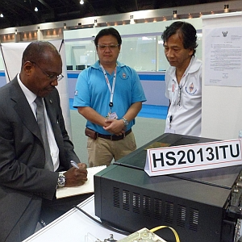
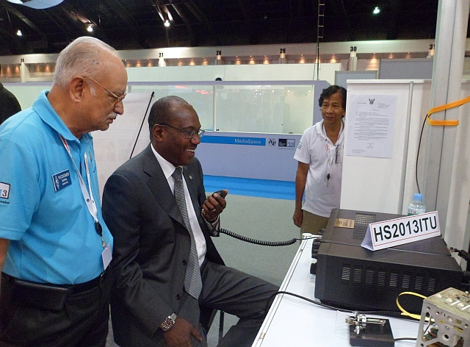
The highlight was the visit of Dr. Hamadoun Toure HB9EHT, Secretary General of ITU who spent some time with us at the booth on 21 November.

Pictured on the left, ITU Secretary General Hamadoun Toure, HB9EHT signs the guest book at the IARU booth during ITU Telecom World 2013 as RAST Secretary Jakkree, HS1FVL and Sakol, HS1JNB look on. On the right Dr Toure takes up the operating position for the station Yaesu FT2000D transceiver radio with its special call sign -- Photos: Tony, HS0ZDX
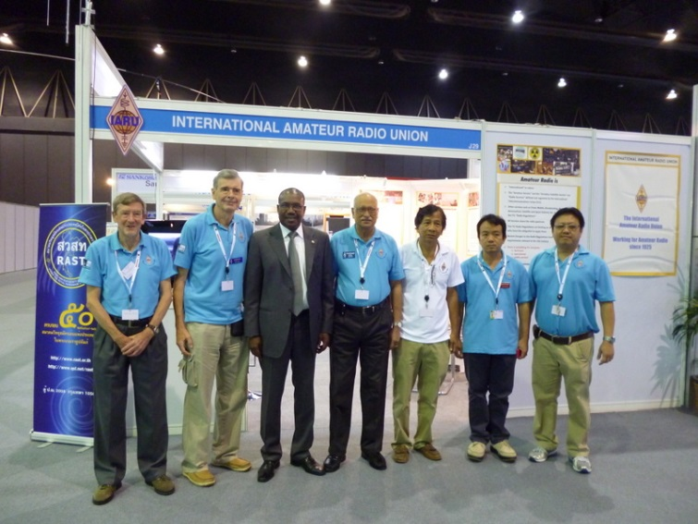

From left: IARU Region 3 Director Peter Lake, ZL2AZ, RAST Vice President Tony Waltham, HS0ZDX, ITU Secretary General Dr Hamadoun Toure, HB9EHT, IARU Region 3 Chairman Gopal Madhavan, VU2GMN, RAST volunteer Sakol Nakin, HS1JNB, RAST volunteer Nikorn Deesai, HS5NMF and RAST Secretary Jakkree Hantongkom, HS1FVL, on 21 November.
The booth was equipped with a large flat TV screen on which videos on amateur radio activities were constantly played. There was also the HF radio connected to a rotary dipole, but being situated inside a large hall with a steel structure roof and walls, hardly any signals made it through. A computer controlled remote station was also set up so that there could be better activity on the HF bands. A VHF radio on the local repeater frequency was also available throughout.
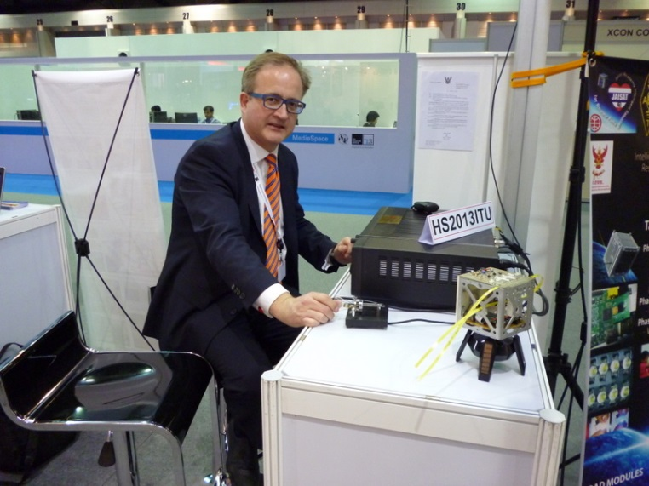
IARU President Tim Ellam VE6SH is shown here operating the special call station. A model of a Cubesat made by RAST is also on display on the right had side of the desk.

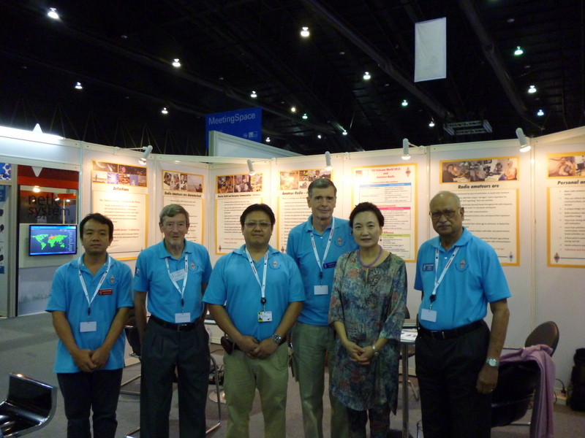
Director of the ITU regional office for Asia in Bangkok Dr Eun-Ju Kim (second from right) poses with IARU Region 3 Chairman Gopal (far right), IARU Region 3 Director Peter Lake (second from left) along with RAST members on 21 November 2013.
The exhibition itself had mainly exhibitors representing various countries and groups of countries. There were many large “pavilions” from the major exhibitors – you could not really call them “booths”, they were huge structures. One major group of pavilions was from Thailand – their regulator the NBTC (National Broadcasting and Telecommunications Commission), Thai landline and cellular companies, other government departments, and an emergency operations centre demonstration set up etc. Another group of pavilions were from a significant number of African countries. There was not that many large commercial entities (Ooreedoo from Qatar, Huawei and others). The IARU booth was in the front of a cluster of other smaller exhibitors. There were also meeting and rest areas and an indoor garden setting etc. The whole exhibition was beautifully laid out and all the exhibit areas were of a very high order.
One aspect that worried all of us was the relative low turnout from visitors. The main attendance was from those who were also participating in the various forum discussions over the four days. The main forum theme was “1 Conversation that matters” – to encourage very high level debate by the leaders attending on the future directions of ICT and telecommunications. IARU President Timothy Ellam was also an invited speaker at one of these sessions. Casual local visitors were put off by a relatively high entry fee by Thai standards, which was a pity. They could have become more knowledgeable and excited about the initiatives planned to develop ICT and telecommunications in Thailand.
The presence of IARU, and its effort to showcase amateur radio and its capabilities, was well appreciated by all who visited the booth and the effort was well worthwhile. This was a unique chance to influence those leaders who can favorably impact the radio regulations and national country attitudes to amateur radio. We also laid a foundation under the new ITU “Telecom World” structure to gain some similar space at the next event in 2014 in Qatar.
(Report by Peter Lake ZL2AZ and Gopal Madhavan VU2GMN)
FOOTNOTES:
Our presence at ITU Telecom World 2013 created some “extra” follow on work for us. The ITU regional office especially asked Gopal VU2GMN to be a speaker at very short notice at an ITU ASP COE Training workshop on “ICT Applications on Mitigating Natural Disasters” on 28 – 29 November 2013 in Hanoi, Vietnam. This was only just over a week’s notice, so we prepared PowerPoint presentations for his two sessions on the run while in Bangkok. Gopal had previously attended and presented with PARA at the “4th APT Workshop on Disaster Management” in Manila in the Philippines in July 2013. Events like this have been excellent opportunities to high light amateur radio and its capabilities, and very topical.
Peter ZL2AZ was asked to help RAST as an advisor on Saturday 23 November, immediately following ITU Telecom World. Their regulator, the NBTC, had recently published draft new Radio Regulations for amateur radio in Thailand. A public forum was held with about 200 amateurs attending from all over Thailand. While the NBTC “objectives” were commendable, many of the “regulations” would negatively impact amateur radio (licensing and type approval of equipment, mobile and portable rules etc.). Peter was able to make introductory comments and offer guidance from an international perspective. Nearly all the proceedings were in Thai, but it was clear that some passionate views were held. A more liberal and open regulatory regime was wanted. NBTC and its Commissioners were listening carefully to these views. More meetings are planned to be held to refine the regulations proposed.
Gopal and Peter were pleased that they were able to be present at these critical times and help with these extra tasks.

